**Creating an Azure Web App and Enabling Security Authentication**

Azure App Service is an HTTP-based service provided by Microsoft Azure for hosting web applications, REST APIs, and mobile back ends. You can develop it in your favourite language, like .NET, .NET Core, Java, Ruby, Node.js, PHP, or Python. It has basically 4 main components as follows :

Here we will discuss only about Azure Web Apps.

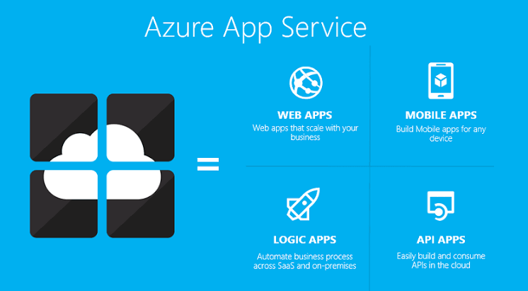

# Thus in this tutorial I will create a Azure Web App and enable the Security Authentication with Azure Active Directory.

**PREREQUISITES**: You need to have an active Azure Subscription. If you not have you can sign-up for a free [**Account**](https://azure.microsoft.com/en-in/free/) **.**

**Task 1st :** Create a Azure Web App.

* Navigate to the [Azure Portal](https://portal.azure.com/).
* Using Search Box present at the top in the centre, search web app.
* You we will see the following results.

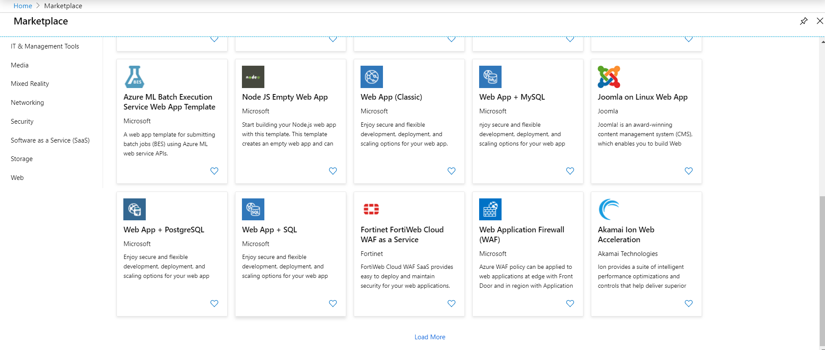

* Choose Web App +SQL .

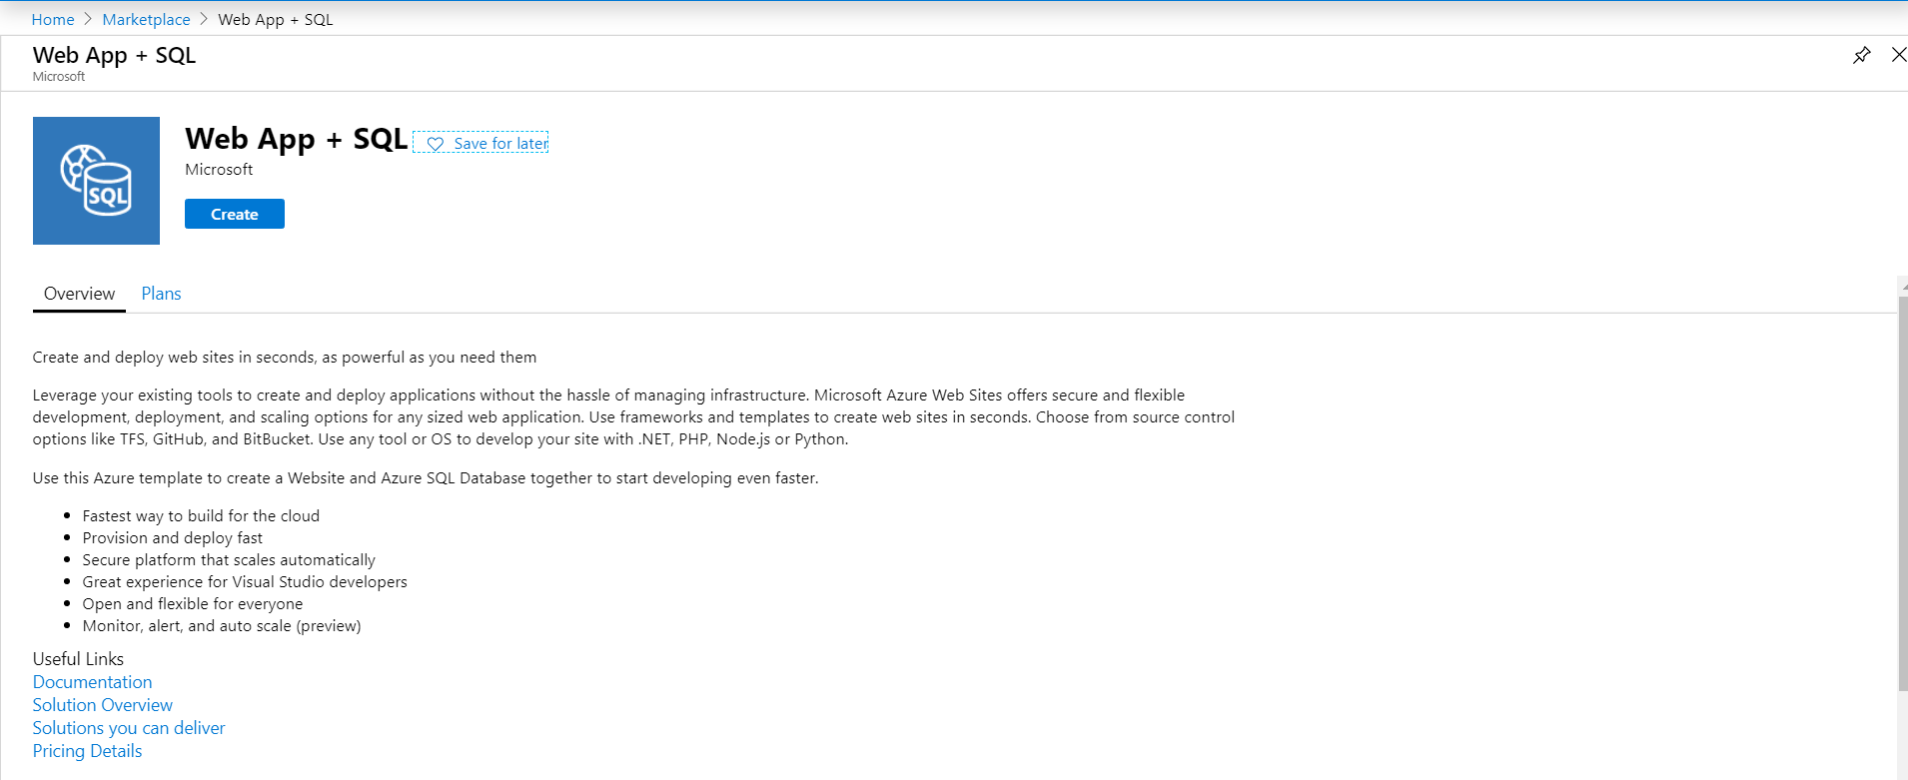

* Click Create.
* Once you click it you will see a Panel that contains following things :
* you need to fill in the following information.

1. App Name: Name of your App.
2. Subscription: Select an existing Microsoft Azure subscription you are having access to.
3. Resource Group: select an existing resource group or create a new one. For more information on resource groups you can refer to the Microsoft documentation on  [Resource groups](https://docs.microsoft.com/en-us/azure/azure-resource-manager/resource-group-overview#resource-groups).
4. App Service Plan/Location: Pick a Location of Your Choice.
5. SQL Database: Choose a existing database or create a new one.
6. Application Insights: Disable it.

**Note** : You need to remember you server Admin login as well as password until you have not saved them in your Microsoft SQL Server Studio.

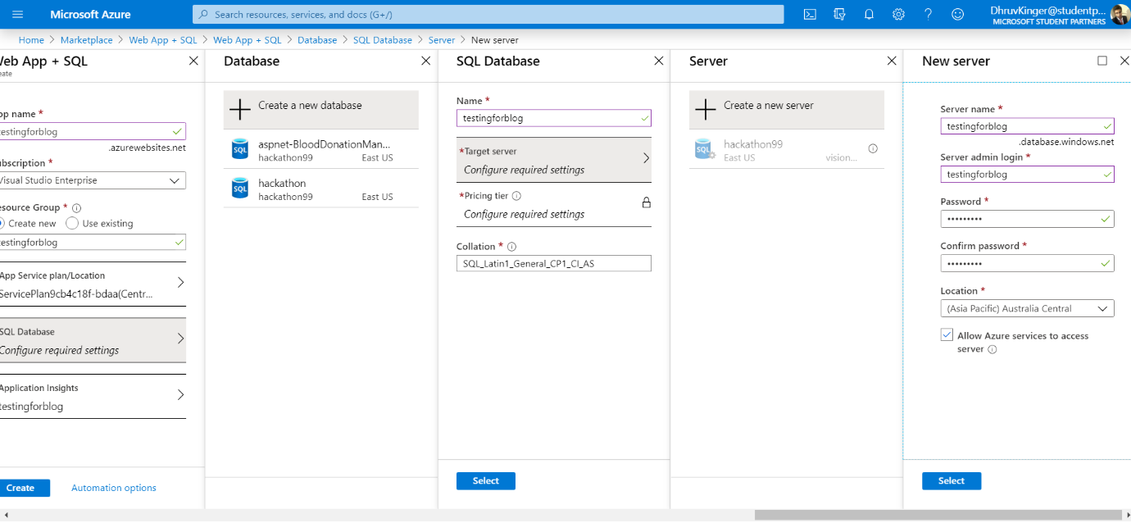

* Here I created a new server ‘testingforblog’ and chosen the location Australia Central.
* Then create the database. Choose the pricing tier as per your choice.

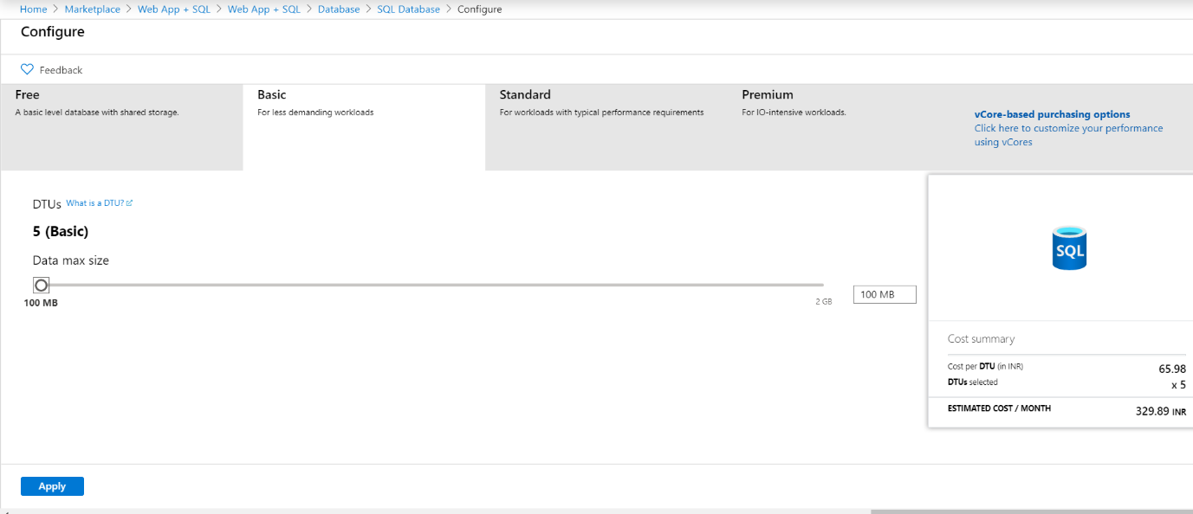

* I have chosen the ‘basic’ plan with 5 ‘DTUs’ and Data Max Size ‘100MB’.

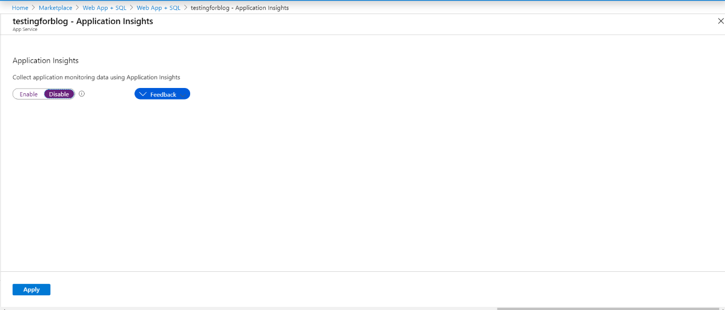

* Disable the Application Insights.

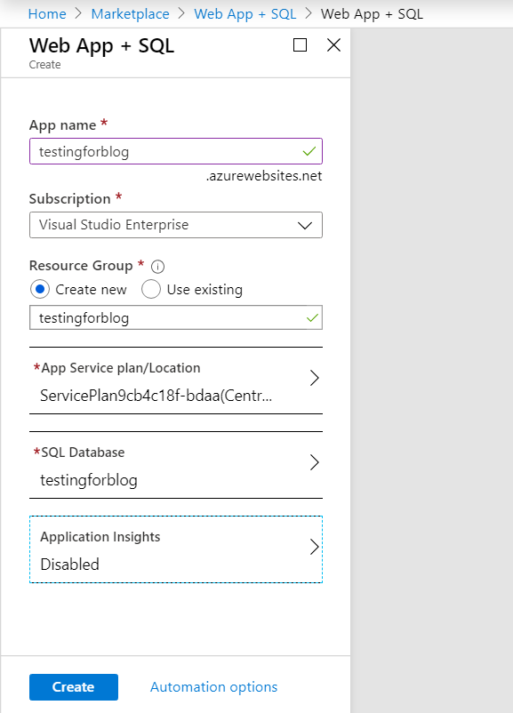

* After filling in this Information. Click Create.
* Pin the Deployed resource to the Dashboard. So,Our 1st task is Completed. Now we will move to our next task.

**Task 2nd :** Add Security Authentication to it.

* Go to Resource testing for blog.
* Click on Settings.
* Choose Authentication/Authorization.
* Enable App Service Authentication.

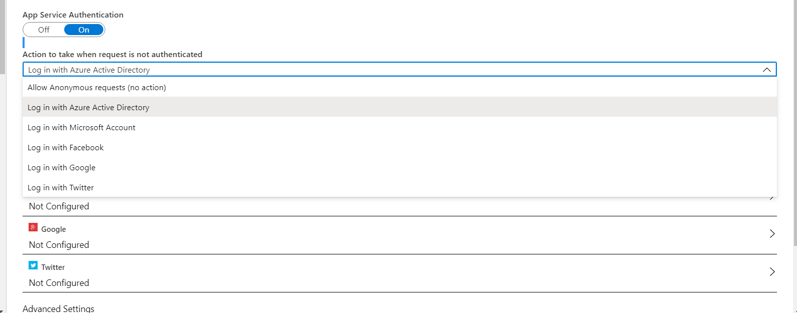

* Configure Azure Active Directory.

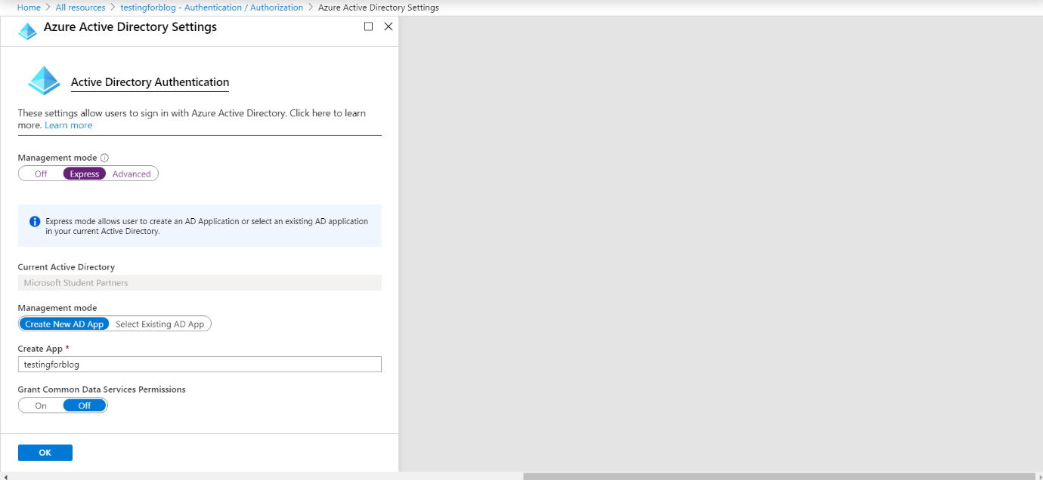

* Select Management Mode as ‘Express’. Create new AD App.
* After finishing we get this screen.

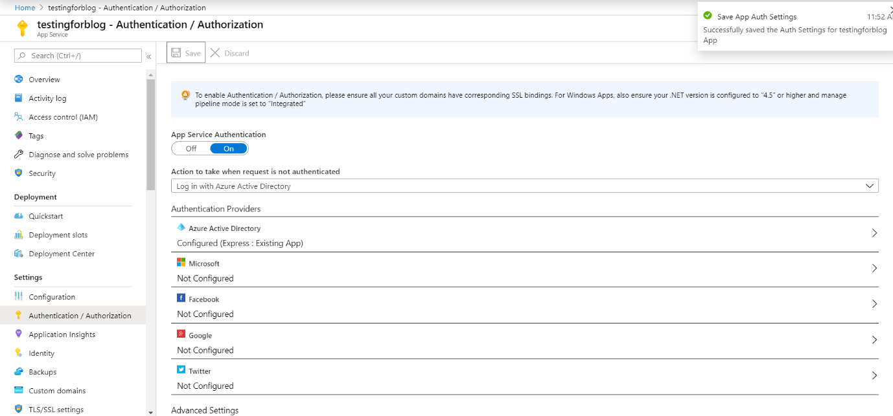

* So, finally we have completed both our tasks.